Lab Guide Vol4 Module 04: Cloud Computing

Scenario
Cloud computing is an emerging technology that delivers computing services such as online business applications, online data storage, and webmail over the Internet. Cloud implementation enables a distributed workforce, reduces organization expenses, provides data security, etc. As enterprises are increasingly adopting cloud services, cloud systems have emerged as targets for attackers to gain unauthorized access to the valuable data stored in them. Therefore, it is essential to regularly perform pen testing on cloud systems to monitor their security posture.
Security administrators claim that cloud systems are more vulnerable to DoS assaults, because they involves numerous individuals or clients, making DoS assaults potentially very harmful. Because of the high workload on a flooded service, these systems attempt to provide additional computational power (more virtual machines, more service instances) to cope with the workload, and they will eventually fail.
Although cloud systems try to thwart attackers by providing additional computational power, they inadvertently aid attackers by allowing the most significant possible damage to the availability of a service—a process that starts from a single flooding-attack entry point. Thus, attackers need not flood all servers that provide a particular service but merely flood a single, cloud-based address to a service that is unavailable. Thus, adequate security is vital in this context, because cloud-computing services are based on sharing.
As an ethical hacker and penetration tester, you must have sound knowledge of hacking cloud platforms using various tools and techniques. The labs in this module will provide you with real-time experience in exploiting the underlying vulnerabilities in a target cloud platform using various hacking methods and tools. However, hacking the cloud platform may be illegal depending on the organization’s policies and any laws that are in effect. As an ethical or pen tester, you should always acquire proper authorization before performing system hacking.

Objective
The objective of the lab is to perform cloud platform hacking and other tasks that include, but are not limited to:
- Performing S3 bucket enumeration
- Exploiting misconfigured S3 buckets
- Escalating privileges of a target IAM user account by exploiting misconfigurations in a user policy

Overview of Cloud Computing
Cloud computing refers to on-demand delivery of IT capabilities, in which IT infrastructure and applications are provided to subscribers as metered services over a network. Cloud services are classified into three categories, namely infrastructure-as-a-service (IaaS), platform-as-a-service (PaaS), and software-as-a-service (SaaS), which offer different techniques for developing cloud.

Lab Tasks
Ethical hackers or pen testers use numerous tools and techniques to hack the target cloud platform. Recommended labs that will assist you in learning various cloud platform hacking techniques include:
- Perform Reconnaissance on Azure
  - Azure reconnaissance with AADInternals
- Exploit S3 buckets
  - Exploit open S3 buckets using AWS CLI
- Perform privilege escalation to gain higher privileges
  - Escalate IAM user privileges by exploiting misconfigured user policy
- Perform vulnerability assessment on Docker images
  - Vulnerability assessment on Docker images using Trivy
Lab 1: Perform Reconnaissance on Azure
Lab Scenario
As an ethical hacker, you need to know how to utilize PowerShell command-based scripting tools for conducting reconnaissance and gathering information. This information can then be used to assess the security posture of other systems within the network.
Lab Objectives
- Azure Reconnaissance with AADInternals
Overview of Reconnaissance Tools
Reconnaissance tools serve as indispensable assets for attackers in cloud hacking, providing them with the essential information and insights needed to orchestrate successful attacks against cloud environments.
Task 1: Azure Reconnaissance with AADInternals
AADInternals is primarily focused on auditing and attacking Azure Active Directory (AAD) environments, it can still be utilized as part of a broader cloud reconnaissance effort. This tool has several features such as user enumeration, credential extraction, token extraction and manipulation, privilege escalation, etc.
In this lab we will perform Azure Active Directory reconnaissance as an outsider.
- Click Windows 11 to switch to the Windows 11 machine. Click Ctrl+Alt+Delete to activate the machine and login with Admin/Pa$$w0rd.
- Navigate to E:\CEH-Tools\CEHv13 Module 19 Cloud Computing\GitHub Tools\ and copy AADInternals folder and paste it on Desktop.
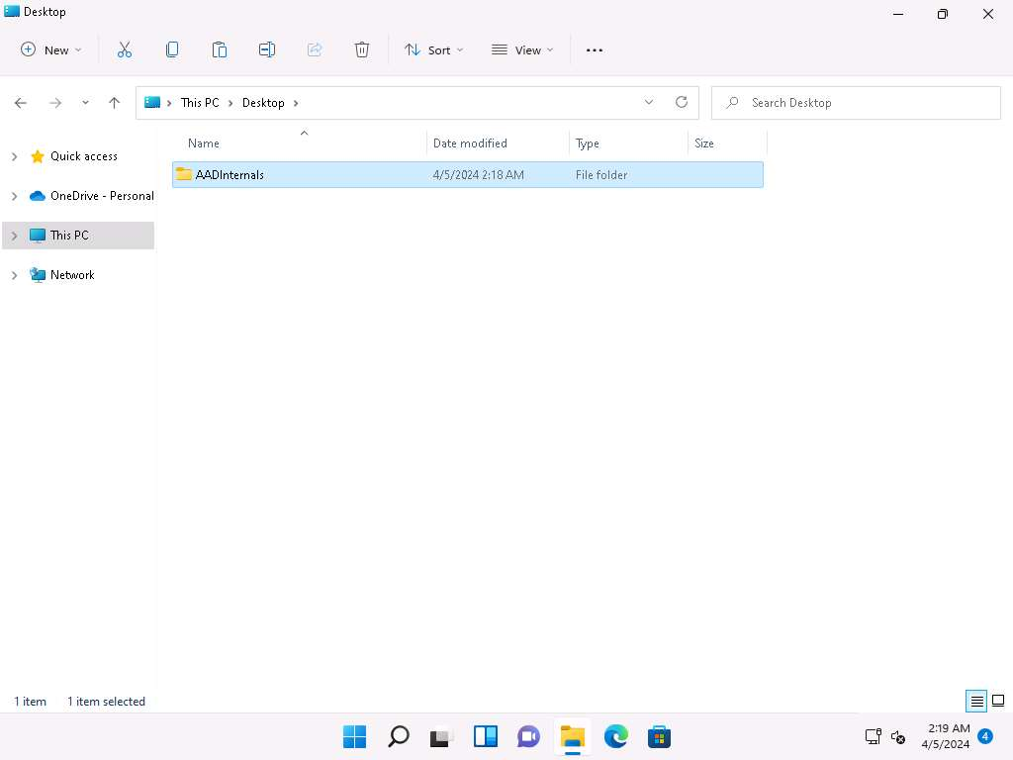
- In the Windows search type powershell and under PowerShell click on Run as Administrator to open an administrator PowerShell window.
If a User Account Control window appears, click Yes.
- In the PowerShell window run cd C:\Users\Admin\Desktop\AADInternals command to navigate to AADInternals folder.
- In the PowerShell window run Install-Module AADInternals command to install AADInternals module.
In the Do you want PowerShellGet to install and import the NuGet provider now? Question type Y and press Enter. In the Are you sure you want to install the modules from "PSGallery”? question type A and press Enter.
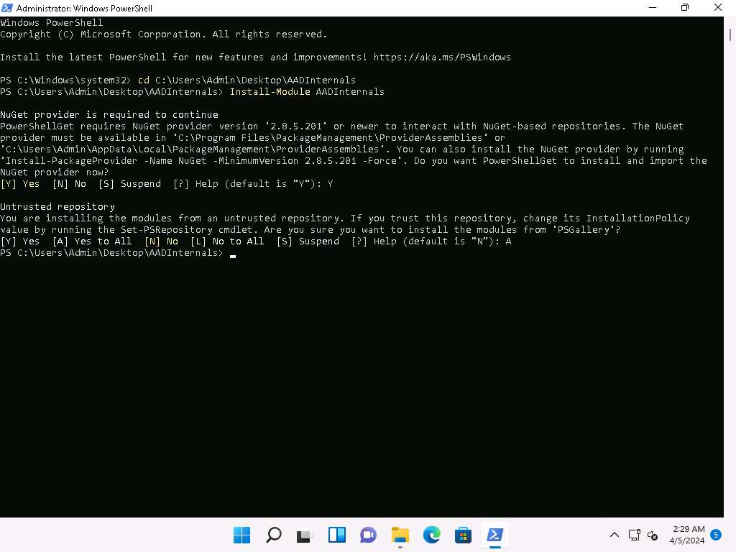
- Now, run Import-Module AADInternals command, to import AADInternals module.
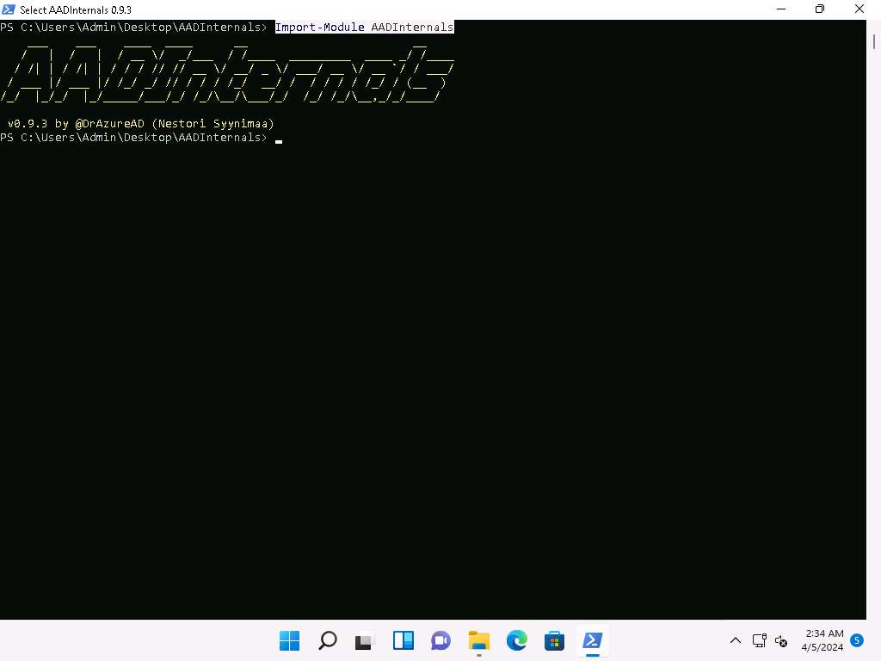
- Now, we will gather the publicly available information of a target Azure AD such as Tenant brand, Tenant name, Tenant ID along with the names of the verified domains.
- In the PowerShell window run Invoke-AADIntReconAsOutsider -DomainName company.com | Format-table command.
In the above command replace the company.com with the target company's domain (here, we are using eccouncil.org).
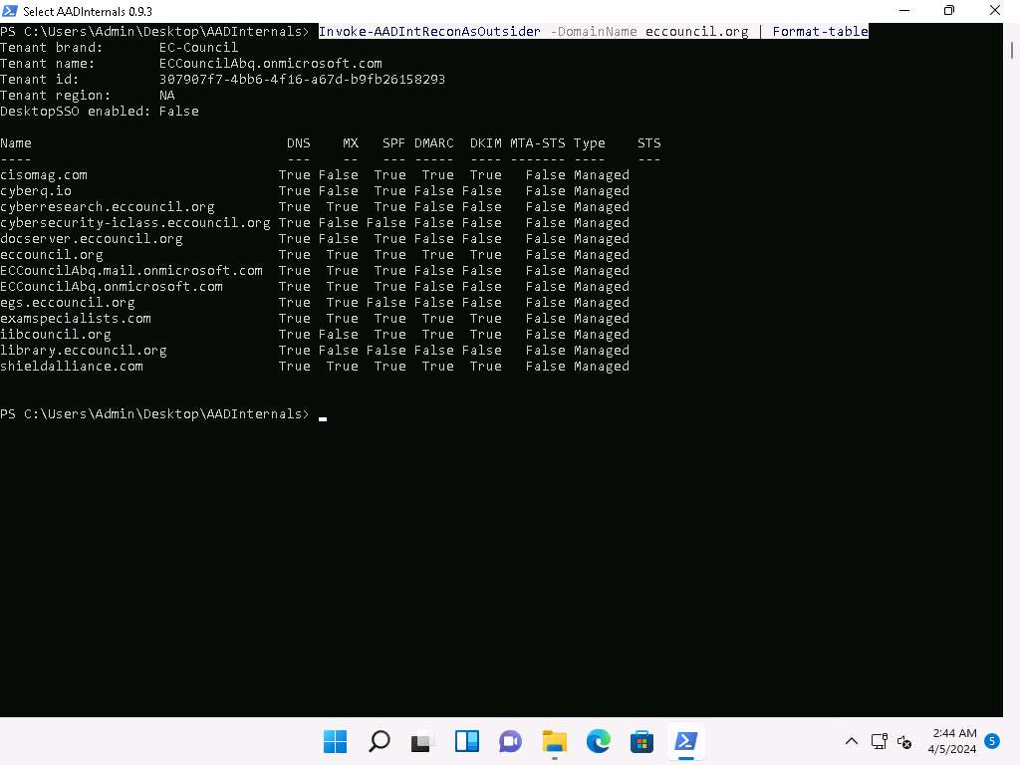
- From the above screenshot we can gather information such as DNS, MX, SPF, DMARC, DKIM etc.
- Now, we will perform user enumeration in Azure AD, in the PowerShell window type Invoke-AADIntUserEnumerationAsOutsider -UserName user@company.com and press Enter.
In the above command replace the user@company.com with the target users email address.
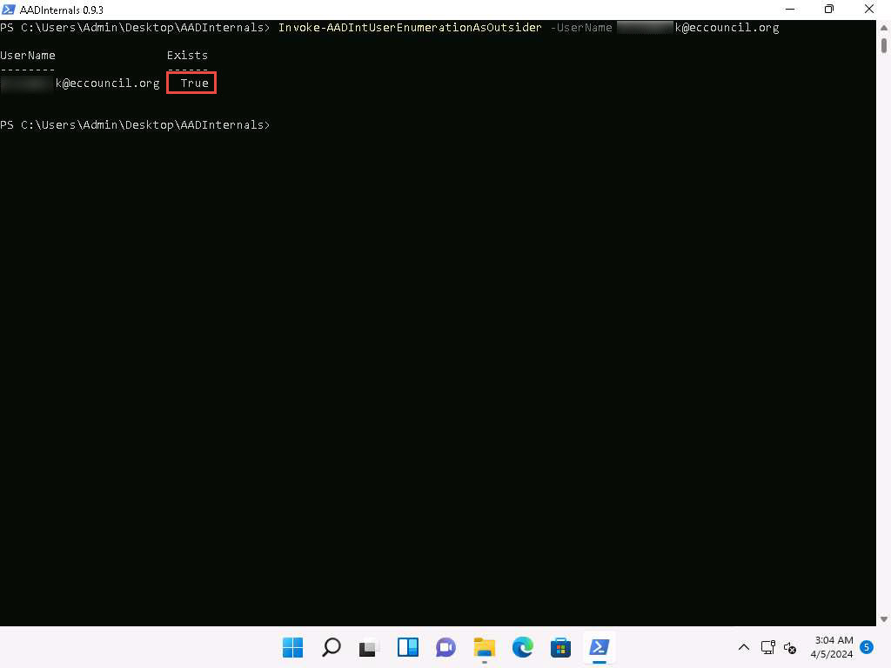
- We can see that the result appears, True under Exists field which implies that the Azure account with the given username exists and the attacker can perform further attacks.
- We can also perform the user enumeration by placing the usernames in a text file, by running Get-Content .\users.txt | Invoke-AADIntUserEnumerationAsOutsider -Method Normal. Where the users.txt file contains the target email addresses.
- Now, to get login information for a domain type Get-AADIntLoginInformation -Domain company.com and press Enter.
In the above command replace the company.com with the target company's domain (here, we are using eccouncil.org).
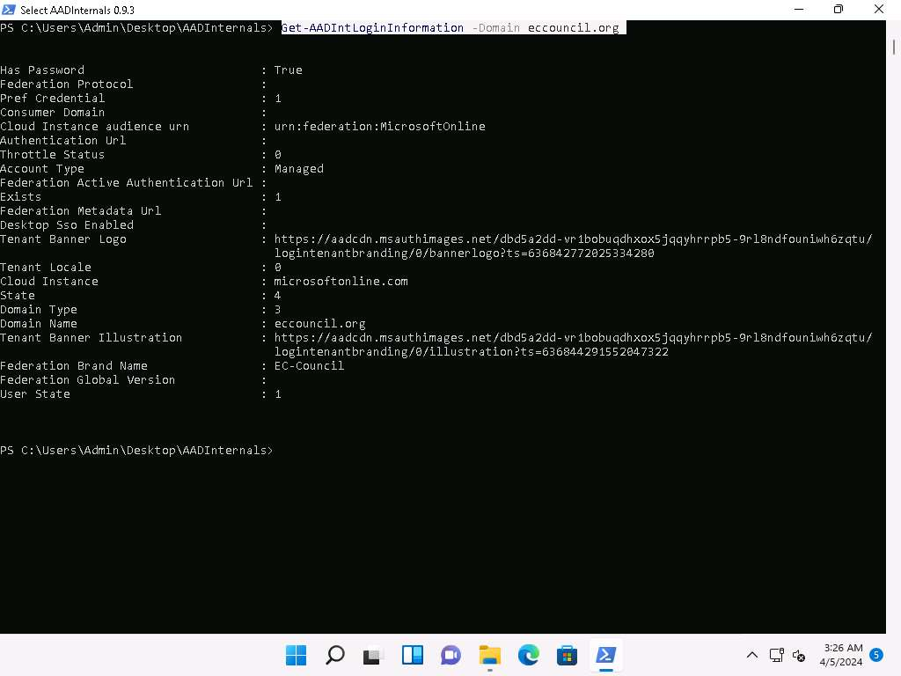
- Now, to get login information for a user type Get-AADIntLoginInformation -Domain user@company and press Enter.
In the above command replace the user@company.com with the target users email address.
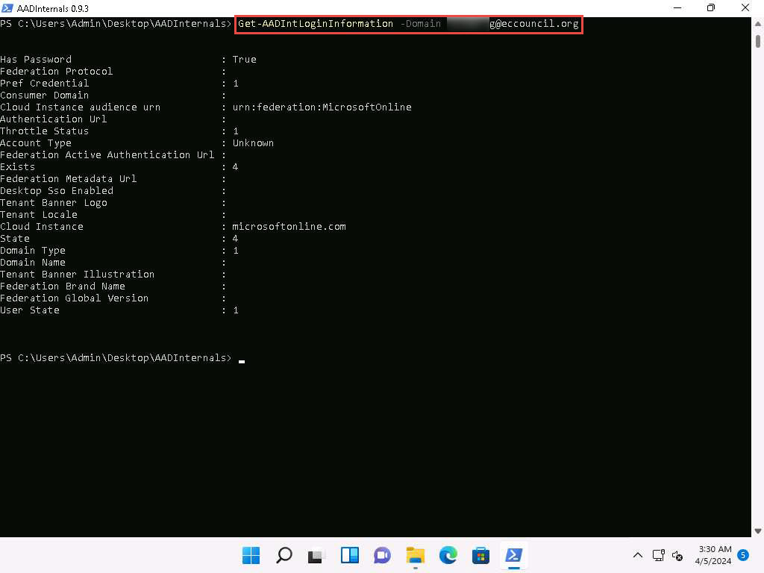
- To get the tenant ID for the given user, domain, or Access Token, type Get-AADIntTenantID -Domain company.com.
In the above command replace the company.com with the target company's domain (here, we are using eccouncil.org).
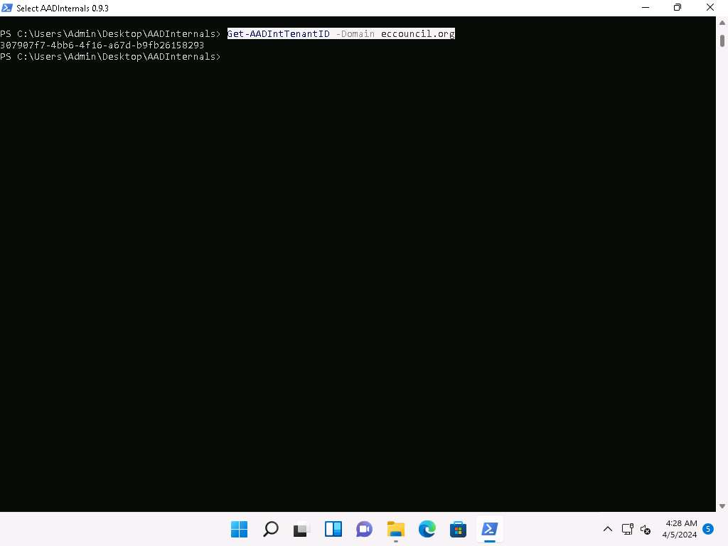
- To get registered domains from the tenant of the given domain Get-AADIntTenantDomains -Domain company.com
In the above command replace the company.com with the target company's domain (here, we are using eccouncil.org).
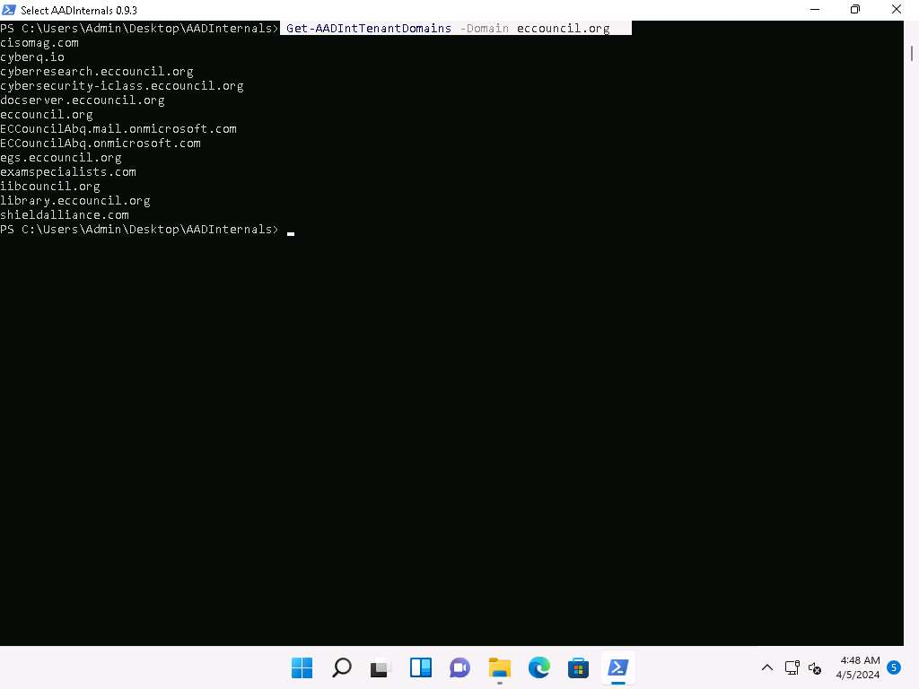
- We can see that all the domains associated with the tenant will be listed.
- Alternatively you can visit https://aadinternals.com/osint/ site and type the tenant ID, domain name, or email to get the openly available information for the given tenant.
- Launch Firefox browser and go to https://aadinternals.com/osint/ and type the domain name in the search box and click on Get information button.
Here we are giving the domain name as eccouncil.org.
- We will get the Domain information and the list of domains connected with the provided domain name.
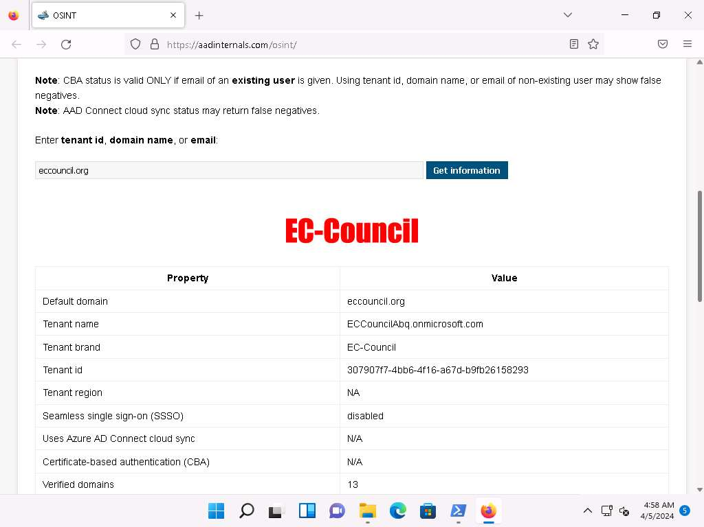
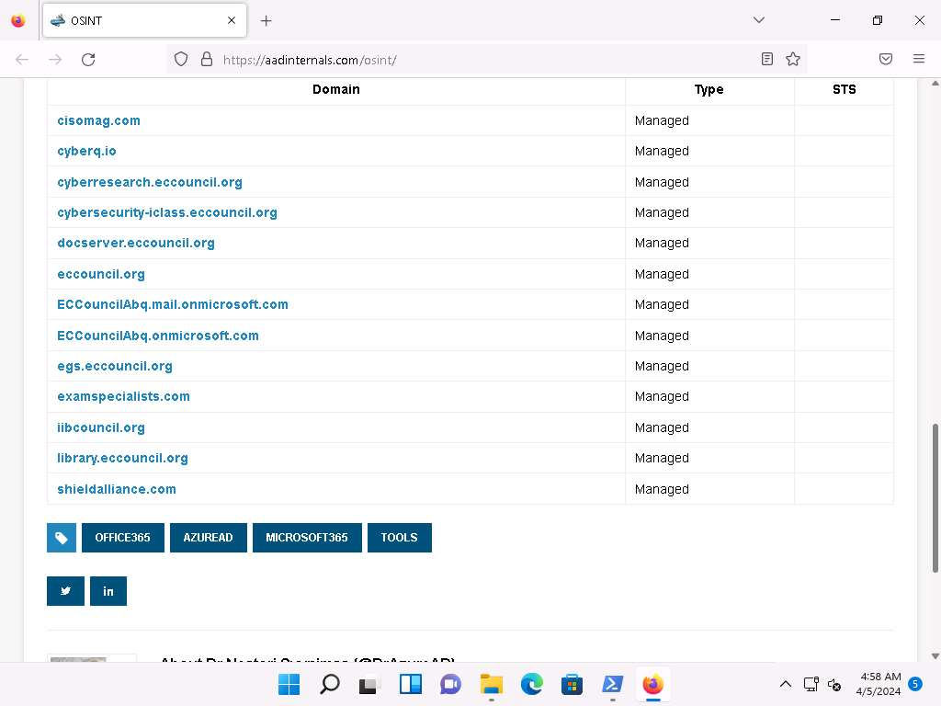
- In similar way you can enter the tenant ID and email in the search field to view the information regarding the tenant and the user.
- This concludes the demonstration of Azure reconnaissance with AADInternals.
- Close all open windows and document all acquired information.
Question 19.1.1.1
On windows 11 machine use AADIntenals tool located at E:\CEH-Tools\CEHv13 Module 19 Cloud Computing\GitHub Tools\ to perform Reconnaissance on Azure AD. While performing user enumeration in Azure AD what does the Exists field display if the user exists.
Lab 2: Exploit S3 Buckets
Lab Scenario
As a professional ethical hacker or pen tester, you must have sound knowledge of enumerating S3 buckets. Using various techniques, you can exploit misconfigurations in bucket implementation and breach the security mechanism to compromise data privacy. Leaving the S3 bucket session running enables you to modify files such as JavaScript or related code and inject malware into the bucket files. Furthermore, finding the bucket’s location and name will help you in testing its security and identifying vulnerabilities in the implementation.
Lab Objectives
- Exploit open S3 buckets using AWS CLI
Overview of S3 Buckets
S3 buckets are used by customers and end users to store text documents, PDFs, videos, images, etc. To store all these data, the user needs to create a bucket with a unique name.
Listed below are several techniques that can be adopted to identify AWS S3 Buckets:
- Inspecting HTML: Analyze the source code of HTML web pages in the background to find URLs to the target S3 buckets
- Brute-Forcing URL: Use Burp Suite to perform a brute-force attack on the target bucket’s URL to identify its correct URL
- Finding subdomains: Use tools such as Findsubdomains and Robtex to identify subdomains related to the target bucket
- Reverse IP Search: Use search engines such as Bing to perform reverse IP search to identify the domains of the target S3 buckets
- Advanced Google hacking: Use advanced Google search operators such as “inurl” to search for URLs related to the target S3 buckets
Task 1: Exploit Open S3 Buckets using AWS CLI
The AWS command line interface (CLI) is a unified tool for managing AWS services. With just one tool to download and configure, you can control multiple AWS services from the command line and automate them through scripts.
Before starting this task, you must create your AWS account (https://aws.amazon.com).
- In the Parrot Security machine, click the MATE Terminal icon in the menu to launch the terminal.
- A Parrot Terminal window appears. In the terminal window, type sudo su and press Enter to run the programs as a root user use toor as password.
The password that you type will not be visible.
- Now, type cd and press Enter to jump to the root directory.
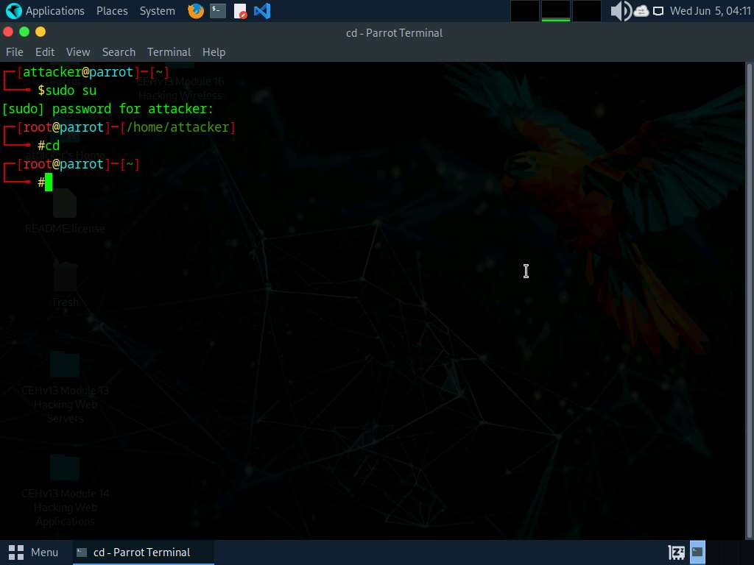
- In the terminal window, type pip3 install awscli and press Enter to install AWS CLI.
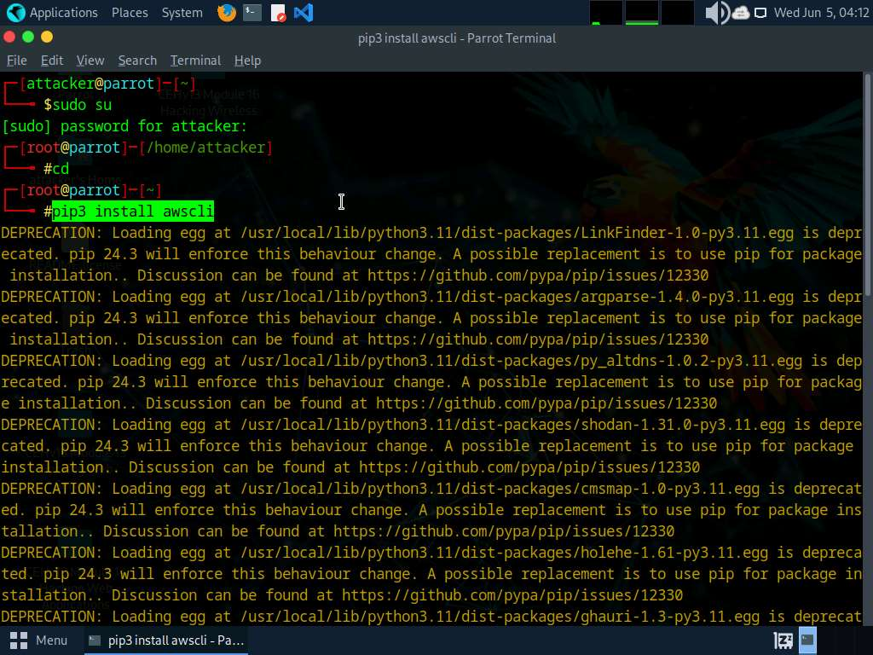
- Now, we need to configure AWS CLI. To configure AWS CLI in the terminal window, type aws configure and press Enter.
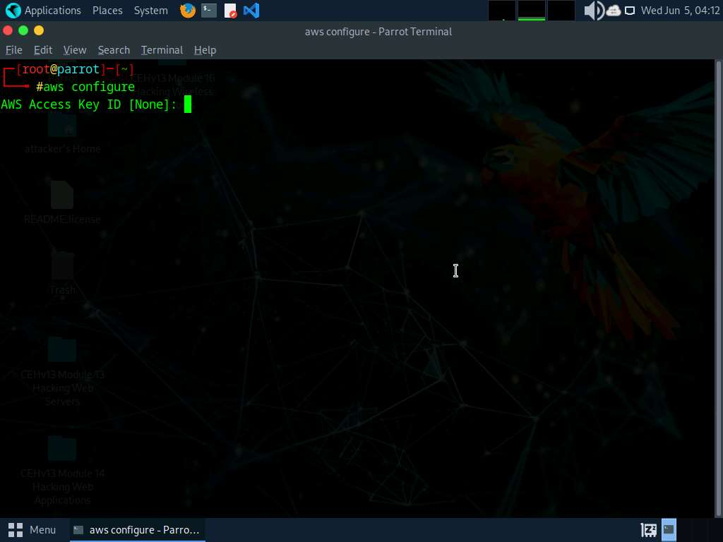
- It will ask for the following details:
  - AWS Access Key ID
  - AWS Secret Access Key
  - Default region name
  - Default output format
- To provide these details, you need to login to your AWS account.
- Click Firefox icon from the top-section of the Desktop.
- Login to your AWS account that you created at the beginning of this task. Click the Firefox browser icon in the menu, type https://console.aws.amazon.com in the address bar, and press Enter.
If you do not have an AWS account, create one with the Basic Free Plan, and then proceed with the tasks.
- The Amazon Web Services Sign-In page appears; type your email account in the Root user email address field and click Next.
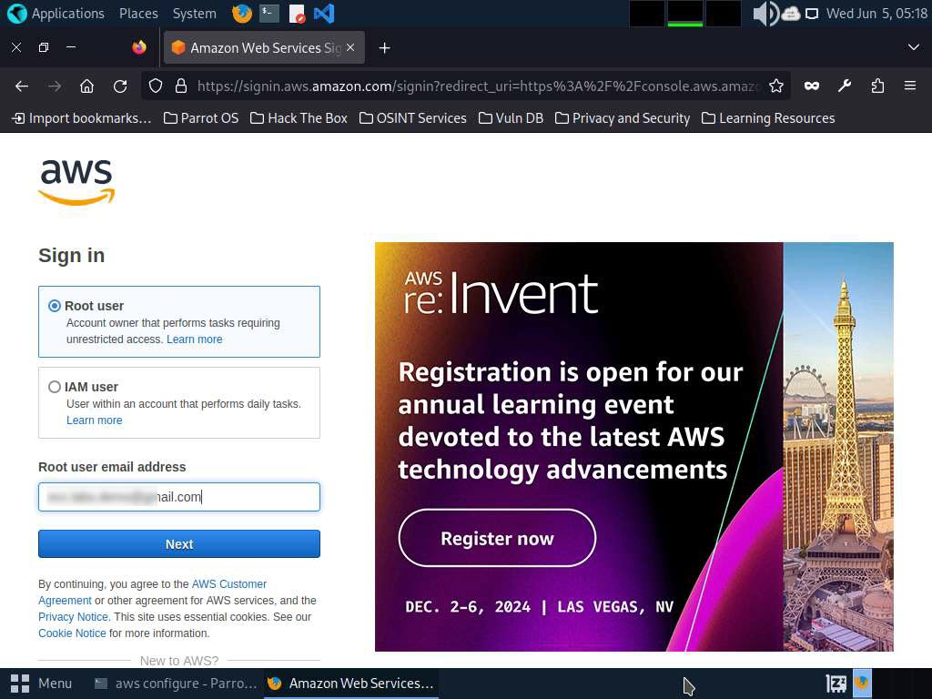
- Type your AWS account password in the Password field and click Sign in.
If a Security check window appears, enter the captcha and click on Submit.
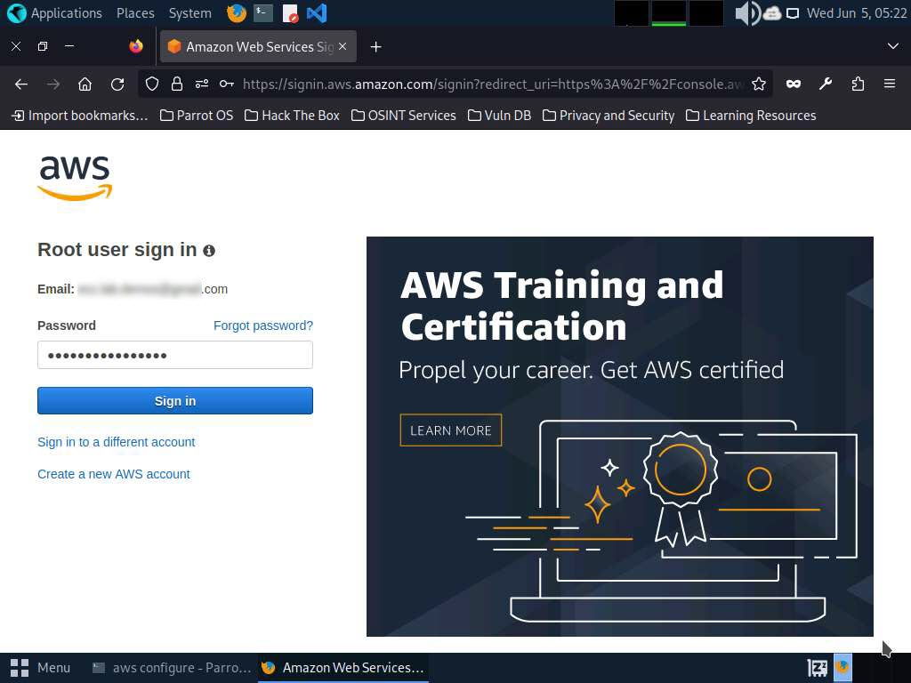
- Click the AWS account drop-down menu and click Security credentials, as shown in the screenshot.
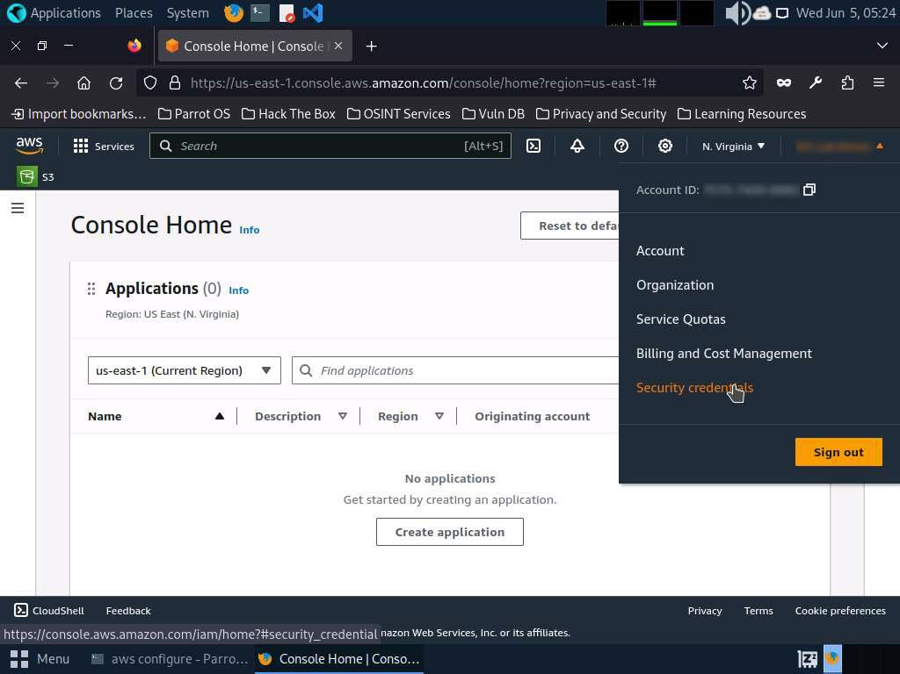
- Scroll down to Access Keys section.
- Click the Create Access Key button. In Continue to create access key?; check the check box and click Create access key.
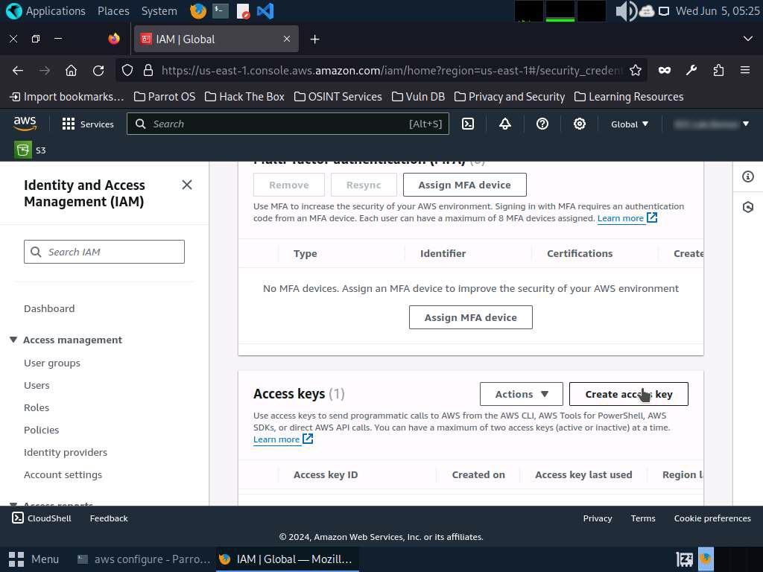
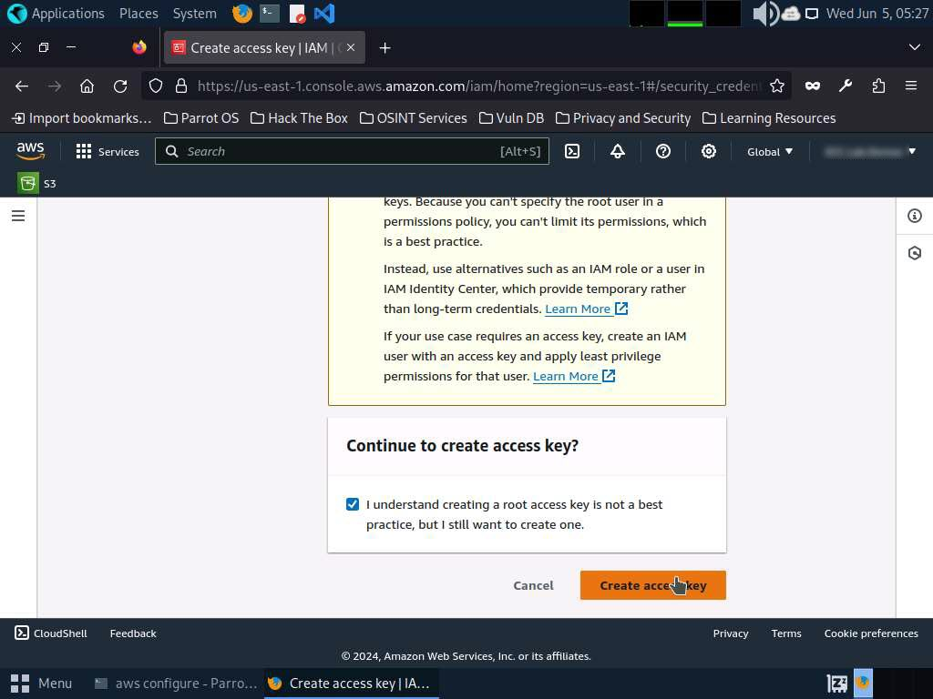
- Copy the Access Key and switch to the Terminal window.
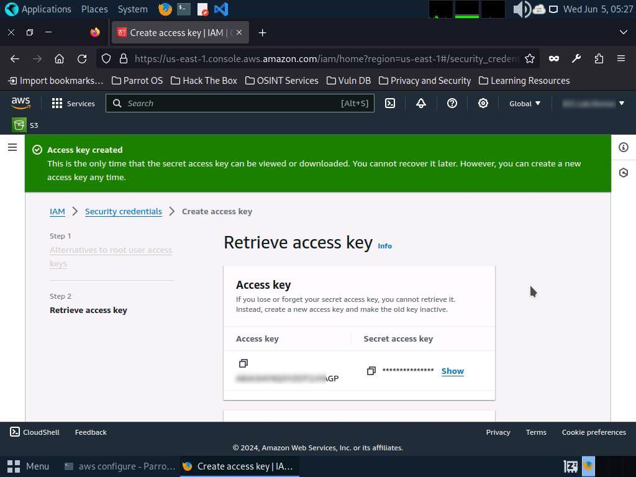
- In the terminal window, right-click your mouse; select Paste from the context menu to paste the copied AWS Access Key ID and press Enter. It will prompt you to the AWS Secret Access Key. Switch to your AWS Account in the browser.
- Copy the Secret Access Key and minimize the browser window. Switch to the Terminal window.
- In the terminal window, right-click your mouse, select Paste from the context menu to paste the copied Secret Access Key and press Enter. It will prompt you for the default region name.
- In the Default region name field, type eu-west-1 and press Enter.
- The Default output format prompt appears; leave it as default and press Enter.
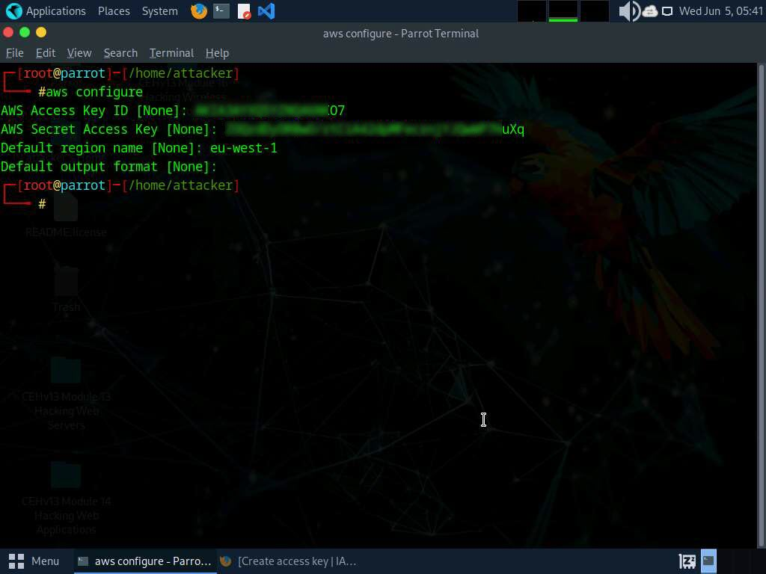
- For demonstration purposes, we have created an open S3 bucket with the name certifiedhacker02 in the AWS service. We are going to use that bucket in this task.
The public S3 buckets can be found during the enumeration phase.
- Let us list the directories in the certifiedhacker02 bucket. In the terminal window, type aws s3 ls s3://[Bucket Name] (here, Bucket Name is certifiedhacker02) and press Enter.
The bucket name may be different in your lab environment depending on the bucket you are targeting.
- This will show you the list of directories in the certifiedhacker02 S3 bucket, as shown in the screenshot.
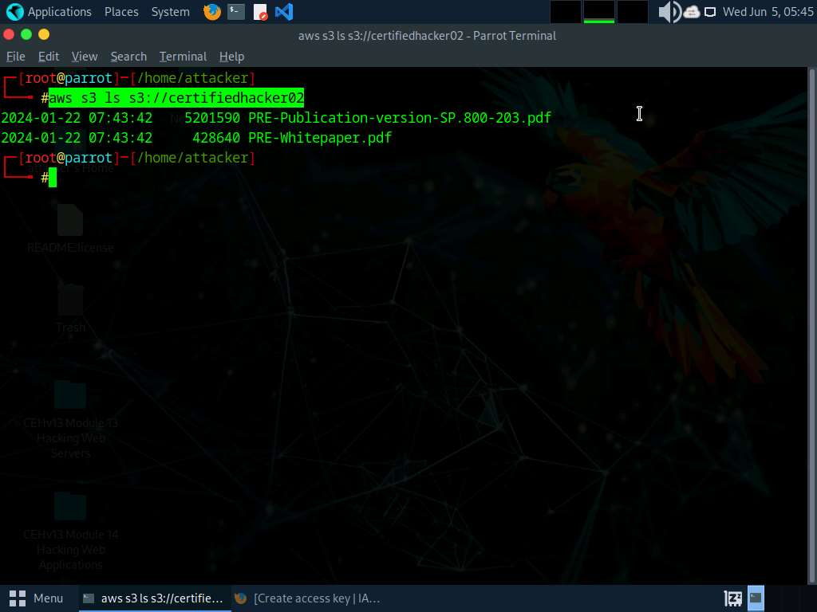
- Now, maximize the browser window, type certifiedhacker02.s3.amazonaws.com in the address bar, and press Enter.
- This will show you the complete list of directories and files available in this bucket.
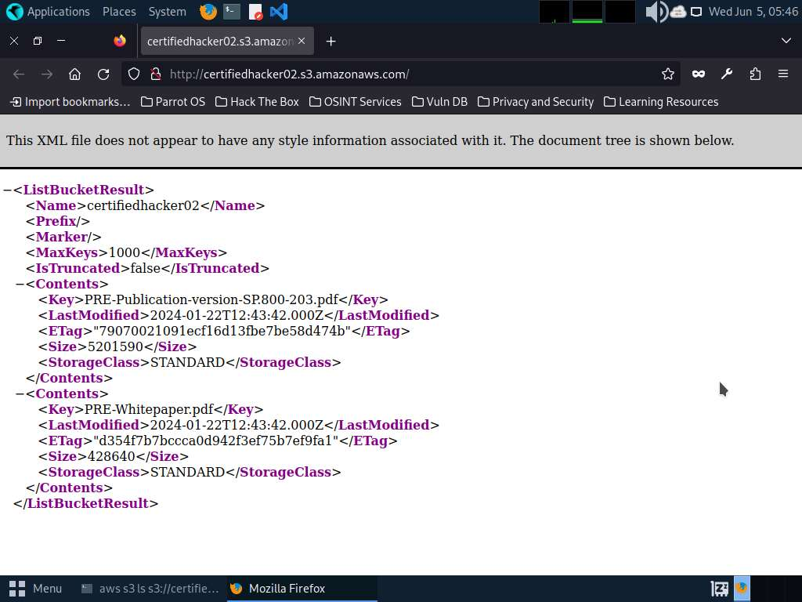
- Minimize the browser window and switch to Terminal.
- Let us move some files to the certifiedhacker02 bucket. To do this, in the terminal window, type echo “You have been hacked” >> Hack.txt and press Enter.
- By issuing this command, you are creating a file named Hack.txt.
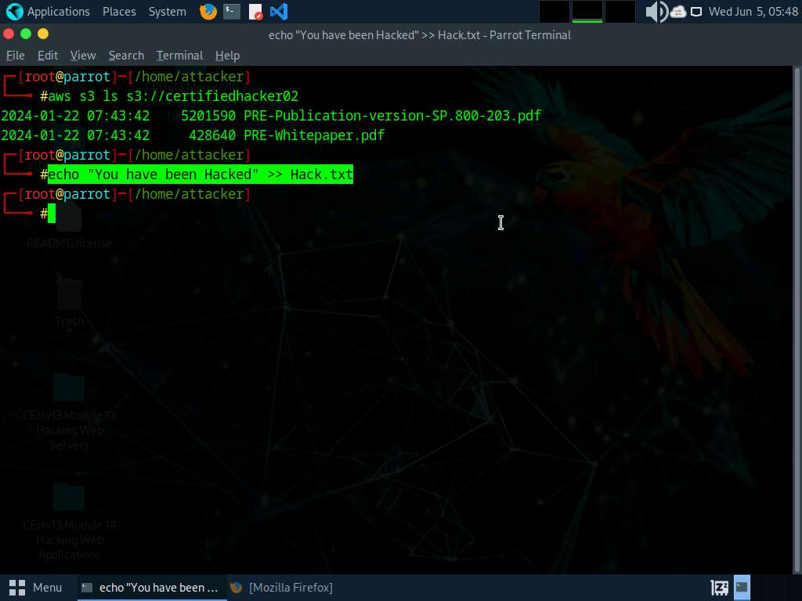
- Let us try to move the Hack.txt file to the certifiedhacker02 bucket. In the terminal window, type aws s3 mv Hack.txt s3://certifiedhacker02 and press Enter.
- You have successfully moved the Hack.txt file to the certifiedhacker02 bucket.
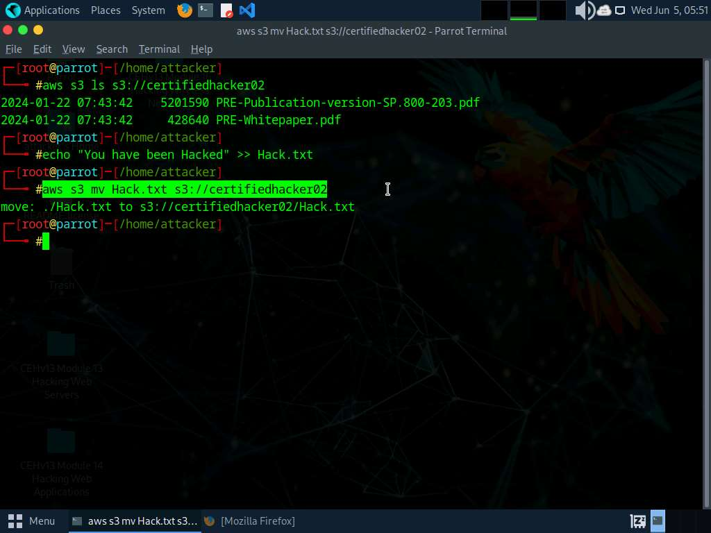
- To verify whether the file is moved, switch to the browser window and maximize it. Reload the page.
- You can observe that the Hack.txt file is moved to the certifiedhacker02 bucket, as shown in the screenshot.
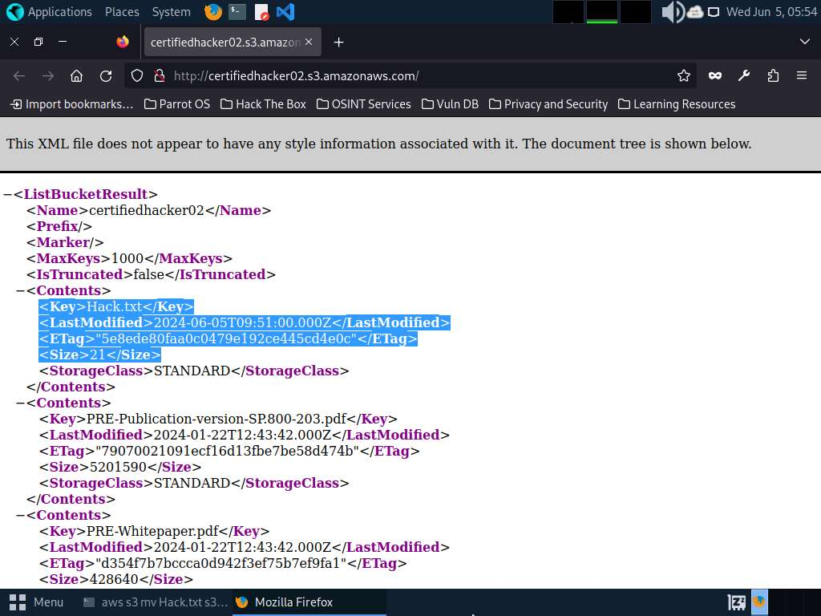
- Minimize the browser window and switch to the Terminal window.
- Let us delete the Hack.txt file from the certifiedhacker02 bucket. In the terminal window, type aws s3 rm s3://certifiedhacker02/Hack.txt and press Enter.
- By issuing this command, you have successfully deleted the Hack.txt file from the certifiedhacker02 bucket.
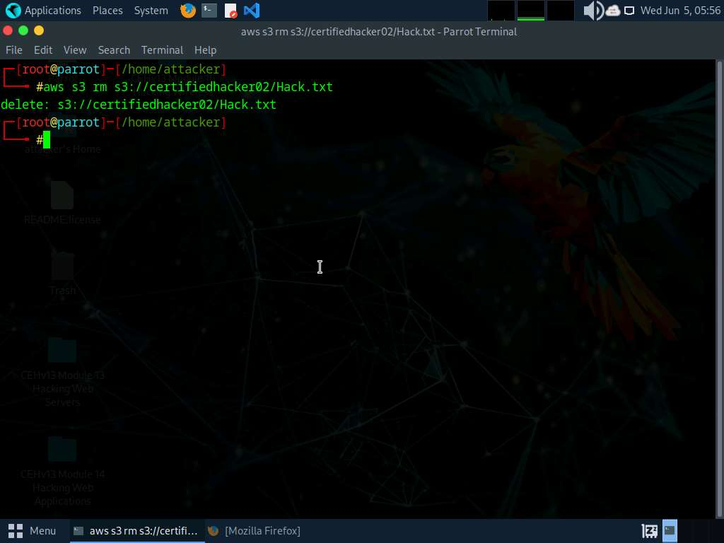
- To verify whether the file is deleted, switch to the browser window and reload the page.
- The Hack.txt file is deleted from the certifiedhacker02 bucket.
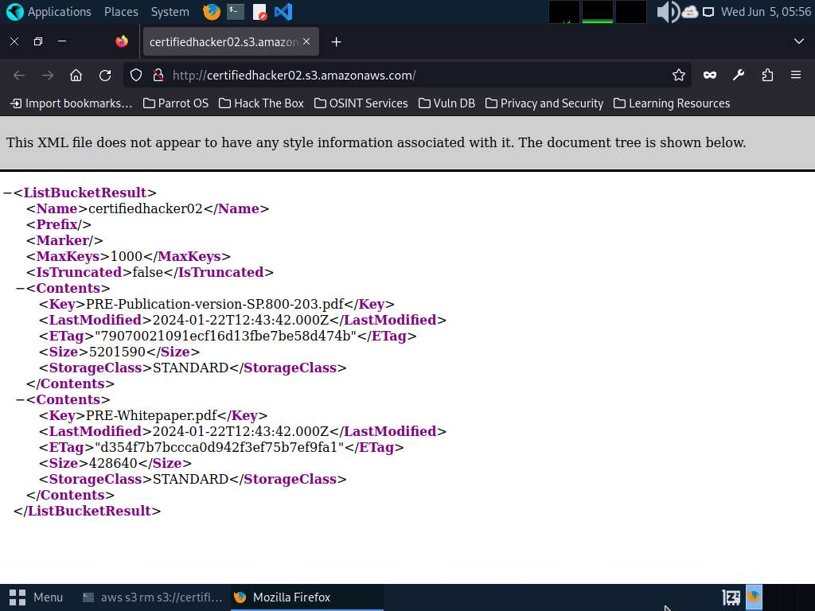
- Thus, you can add or delete files from open S3 buckets.
- This concludes the demonstration of exploiting public S3 buckets.
- Do not end the lab as we will be continuing it in next #Task.
Question 19.2.1.1
Use the AWS CLI tool to exploit open S3 buckets (certifiedhacker1) in the AWS service. Find the total number of files available in the “certifiedhacker1” S3 bucket. Note: You must create an AWS account (https://aws.amazon.com) to perform this task. Enter the command that was used in this lab to list the contents of certifiedhacker02 bucket.

Lab 3: Perform Privilege Escalation to Gain Higher Privileges
Lab Scenario
As a professional ethical hacker or pen tester, you must try to escalate privileges by employing a user account access key and secret access key obtained using various social engineering techniques. In privilege escalation, you attempt to gain complete access to the target IAM user’s account and, then try to attain higher-level privileges in the AWS environment.
In the cloud platform, owing to mistakes in the access allocation system such as coding errors and design flaws, a customer, a third party, or an employee can obtain higher access rights than those that they are authorized to use. This threat arises, because of authentication, authorization, and accountability (AAA) vulnerabilities, user provisioning and de-provisioning vulnerabilities, hypervisor vulnerabilities, unclear roles and responsibilities, misconfiguration, etc.
In this lab, we will exploit a misconfigured user permission policy to escalate privileges to the administrator level.
Lab Objectives
- Escalate IAM user privileges by exploiting misconfigured user policy
Overview of Privilege Escalation
Privileges are security roles assigned to users for using specific programs, features, OSes, functions, files, code, etc. to limit access depending on the type of user. Privilege escalation is required when you want to access system resources that you are not authorized to access. It takes place in two forms: vertical and horizontal.
- Horizontal Privilege Escalation: An unauthorized user tries to access the resources, functions, and other privileges of an authorized user who has similar access permissions
- Vertical Privilege Escalation: An unauthorized user tries to access the resources and functions of a user with higher privileges such as application or site administrators
Task 1: Escalate IAM User Privileges by Exploiting Misconfigured User Policy
A policy is an entity that, when attached to an identity or resource, defines its permissions. You can use the AWS Management Console, AWS CLI, or AWS API to create customer-managed policies in IAM. Customer-managed policies are standalone policies that you administer in your AWS account. You can then attach the policies to the identities (users, groups, and roles) in your AWS account. If the user policies are not configured properly, they can be exploited by attackers to gain full administrator access to the target user’s AWS account.
You need to configure aws cli for this lab refer to Lab 2: Exploit S3 Buckets, Task 1: Exploit Open S3 Buckets using AWS CLI, Steps#1-20.
Before starting this task, create an IAM user (Test) with default settings and create a policy (Test) with permissions including, iam:AttachUserPolicy, iam:ListUserPolicies, sts:AssumeRole, and iam:ListRoles, as shown in the below screenshot. These policies can be exploited by attackers to gain administrator-level privileges. 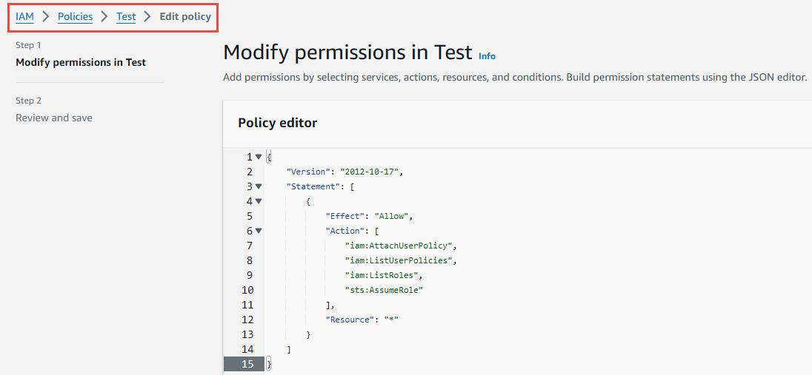
- In the Parrot Security machine, click the MATE Terminal icon in the menu to launch the terminal.
- A Parrot Terminal window appears. In the terminal window, type sudo su and press Enter to run the programs as a root user and user toor as password.
- After configuring the AWS CLI, we create a user policy and attach it to the target IAM user account to escalate the privileges.
- In the terminal window, type vim user-policy.json and press Enter.
This command will create a file named user-policy in the attacker directory.
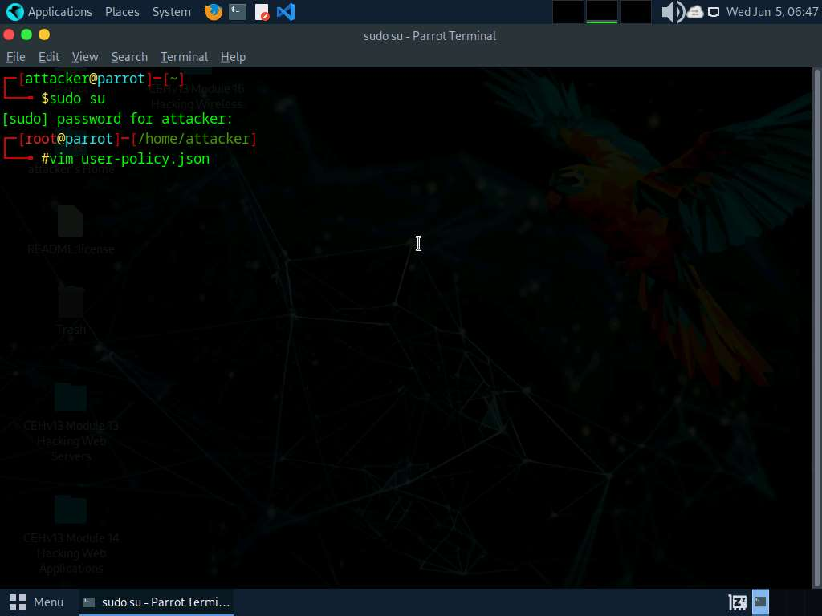
- A command line text editor appears; press I and type the script given below:
{
TypeCopy
"Version":"2012-10-17",

"Statement": [

"Effect":"Allow",

"Action":"*",

"Resource":"*"

}
]
}
This is an AdministratorAccess policy that gives administrator access to the target IAM user.
Ignore the $ symbols in the script.
- After entering the script given in the previous step, press the Esc button. Then, type :wq! and press Enter to save the text document.
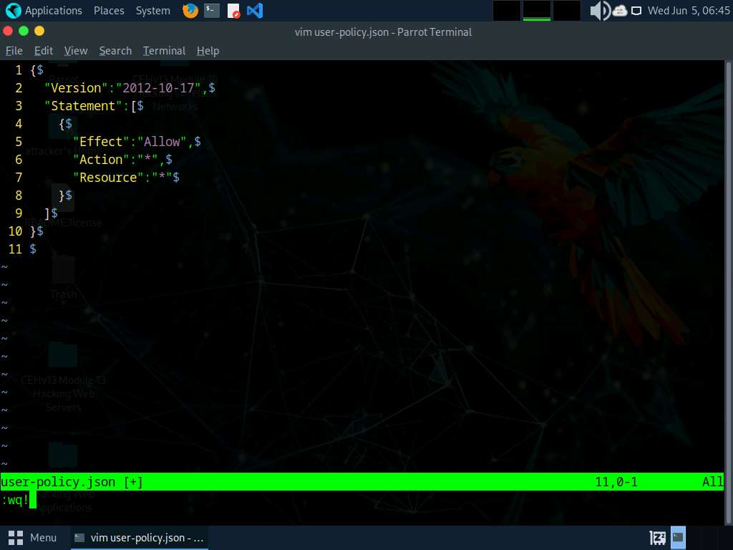
- Now, we will attach the created policy (user-policy) to the target IAM user’s account. To do so, type aws iam create-policy --policy-name user-policy --policy-document file://user-policy.json and press Enter.
If you receive an error that policy already exists, rename the file and try again.
- The created user policy is displayed, showing various details such as PolicyName, PolicyId, and Arn.
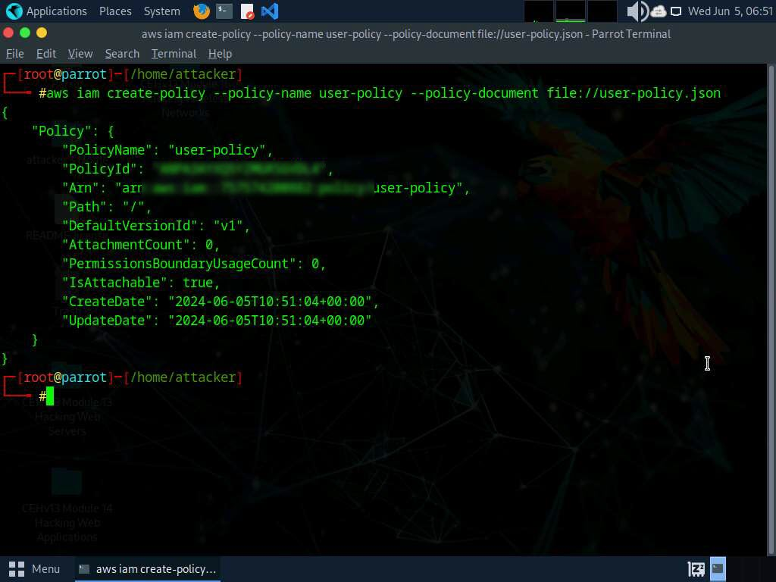
- In the terminal, type aws iam attach-user-policy --user-name [Target Username] --policy-arn arn:aws:iam::[Account ID]:policy/user-policy and press Enter.
- The above command will attach the policy (user-policy) to the target IAM user account (here, test).
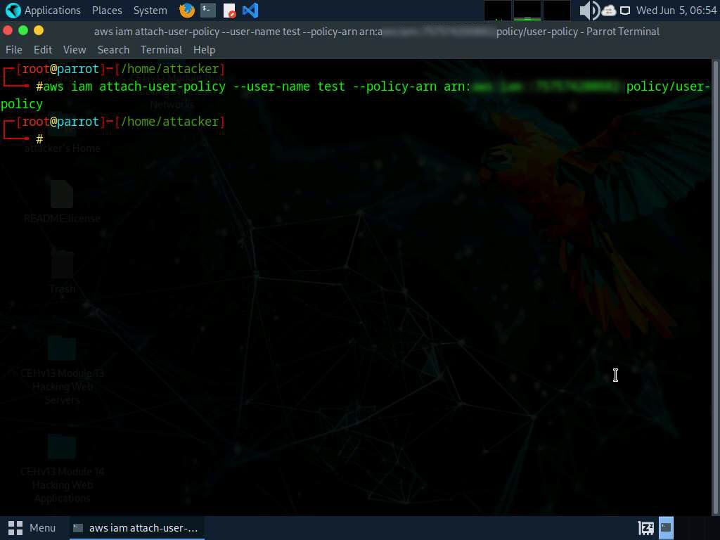
- Now, type aws iam list-attached-user-policies --user-name [Target Username] and press Enter to view the attached policies of the target user (here, test).
- The result appears, displaying the attached policy name (user-policy), as shown in the screenshot.
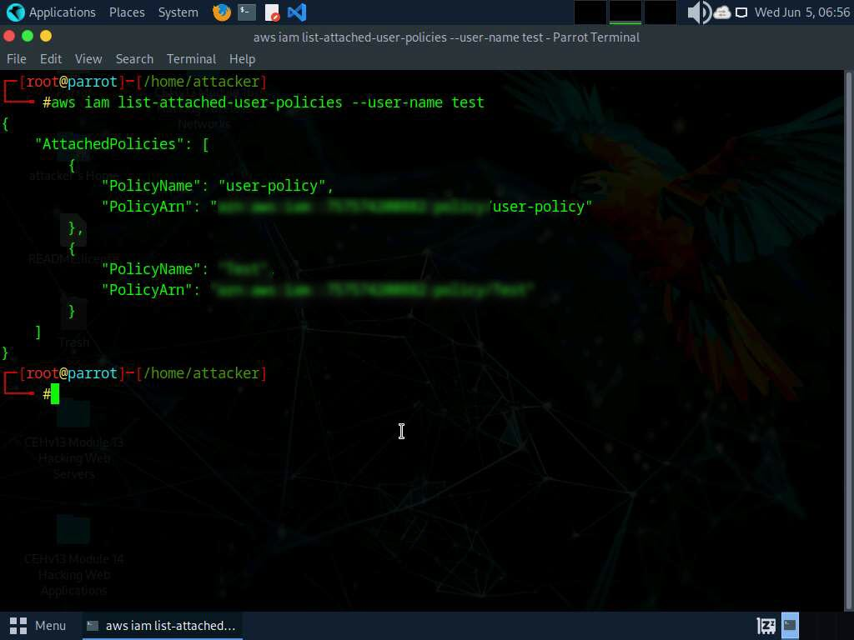
- Now that you have successfully escalated the privileges of the target IAM user account, you can list all the IAM users in the AWS environment. To do so, type aws iam list-users and press Enter.
- The result appears, displaying the list of IAM users, as shown in the screenshot.
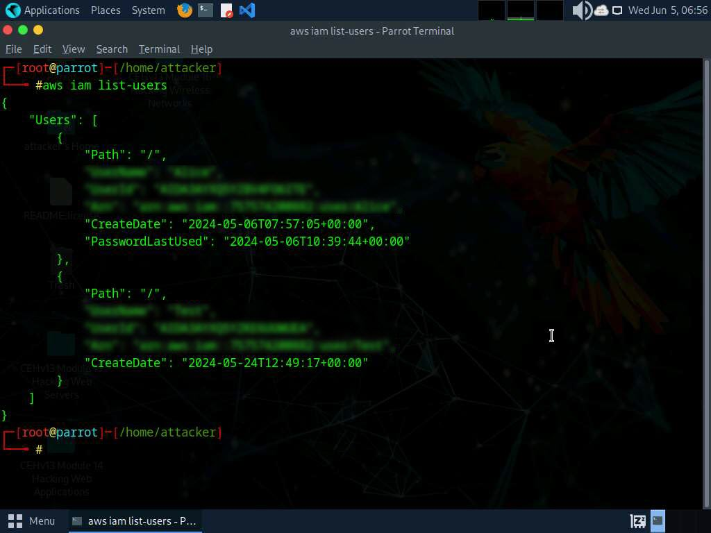
- Similarly, you can use various commands to obtain complete information about the AWS environment such as the list of S3 buckets, user policies, role policies, and group policies, as well as to create a new user.
  - List of S3 buckets: aws s3api list-buckets --query "Buckets[].Name"
  - User Policies: aws iam list-user-policies
  - Role Policies: aws iam list-role-policies
  - Group policies: aws iam list-group-policies
  - Create user: aws iam create-user
- This concludes the demonstration of escalating IAM user privileges by exploiting a misconfigured user policy.
- Close all open windows and document all acquired information.
Question 19.3.1.1
Escalate IAM user privileges by exploiting a misconfigured user policy. Which aws command will list all user policies?
Lab 4: Perform Vulnerability Assessment on Docker Images
Lab Scenario
As a professional ethical hacker or pen tester, expertise in Docker vulnerability assessment is crucial. By leveraging tools like Trivy, you can analyze Docker images, identifying and exploiting vulnerabilities. Active scanning and manual inspection reveal weak configurations, enabling you to breach security and implant malicious code, while understanding image location aids in comprehensive security testing and mitigation.
Lab Objectives
- Vulnerability assessment on Docker images using Trivy
Overview of Docker Images
Docker images are lightweight, standalone, executable packages that contain everything needed to run a software application, including the code, runtime, libraries, and dependencies. They enable consistent deployment across various environments, simplify software distribution, and facilitate scalability and reproducibility in containerized environments.
Task 1: Vulnerability Assessment on Docker Images using Trivy
Trivy is a powerful security scanner that detects vulnerabilities and misconfigurations across a wide range of targets, including container images, file systems, Git repositories, virtual machine images, Kubernetes, and AWS. With its comprehensive scanners, Trivy identifies OS package vulnerabilities, sensitive information, IaC issues, and more, providing a robust security solution for your infrastructure.
- In the Parrot Security machine, click the MATE Terminal icon in the menu to launch the terminal.
- A Parrot Terminal window appears. In the terminal window, type sudo su and press Enter to run the programs as a root user.
- In the [sudo] password for attacker field, type toor as a password and press Enter.
The password that you type will not be visible.
Minimise the terminal for better view of output
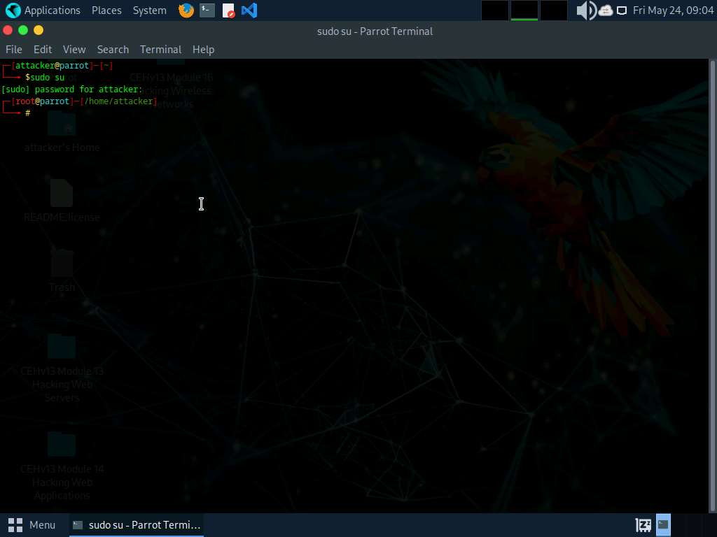
- In this lab we will be scanning two docker images, first the secure one and second the vulnerable one.
- Execute command docker pull ubuntu to install the first docker image.
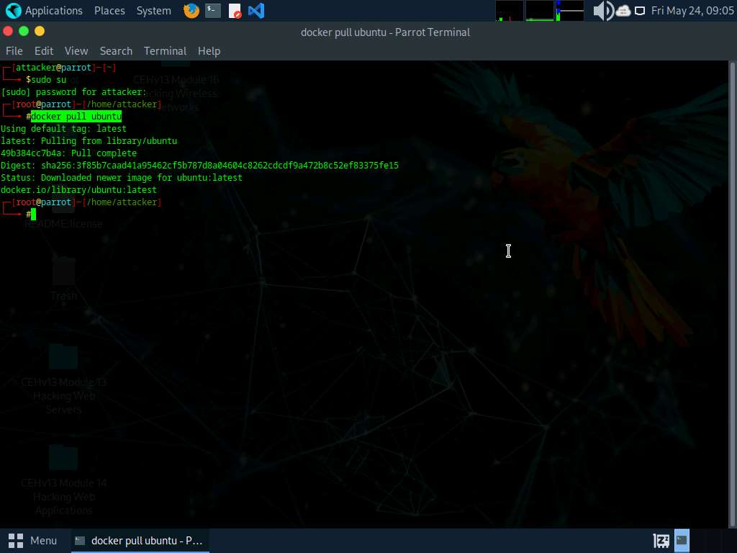
- Once the image is pulled we will be performing vulnerability assessment. Execute command trivy image ubuntu.
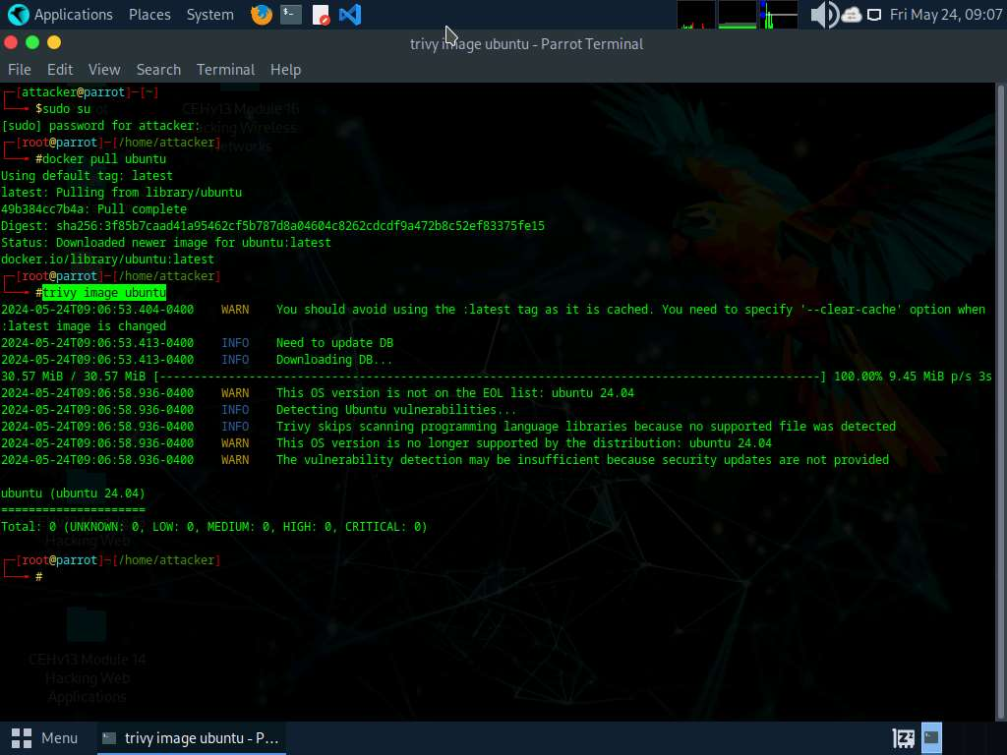
- In the above screenshot, we can observe that we have total 0 vulnerability and it's completely secure.
- Now, we will analyse the vulnerbale image. execute command docker pull nginx:1.19.6 to pull the vulnerable image.
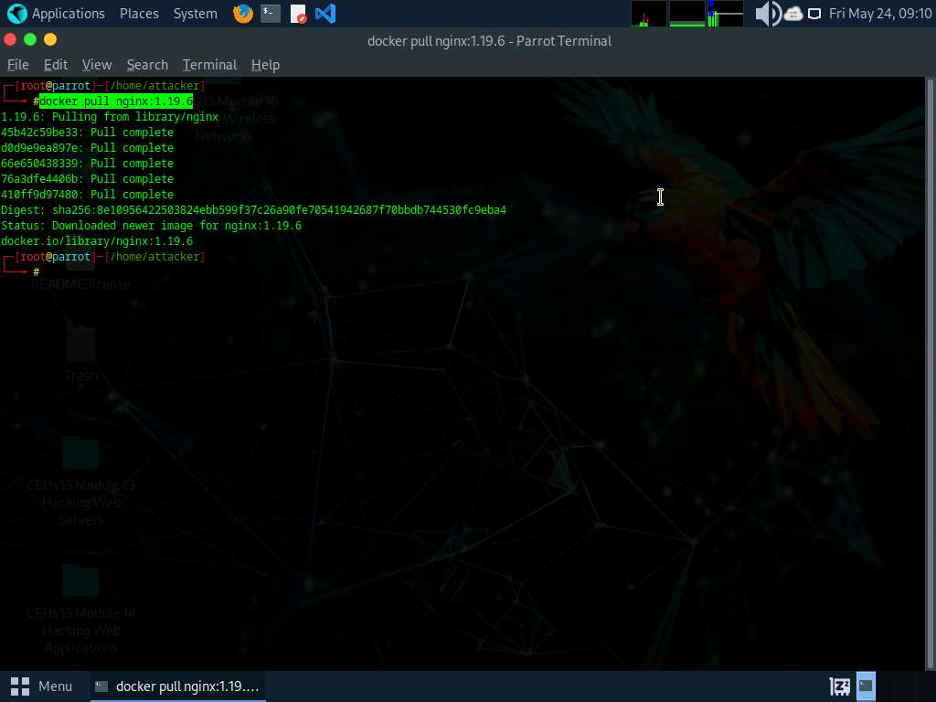
- Execute command trivy image nginx:1.19.6 to scan the image.
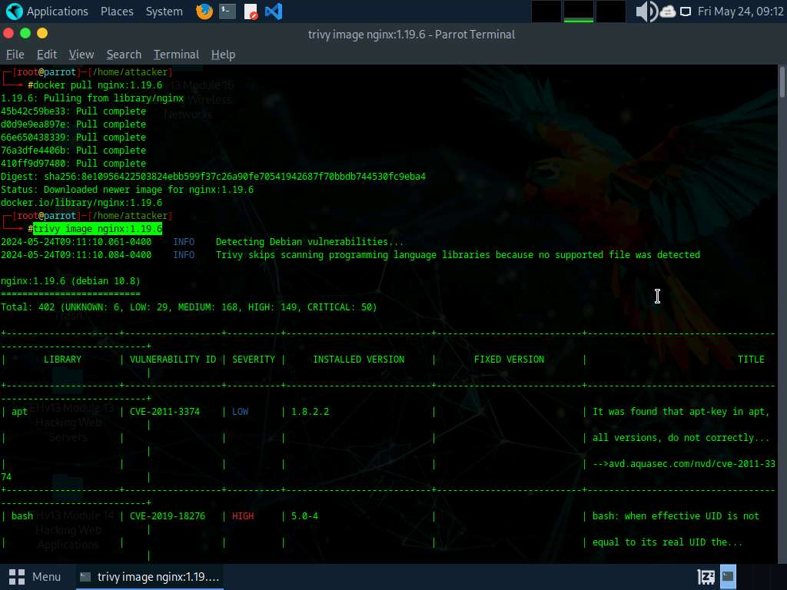
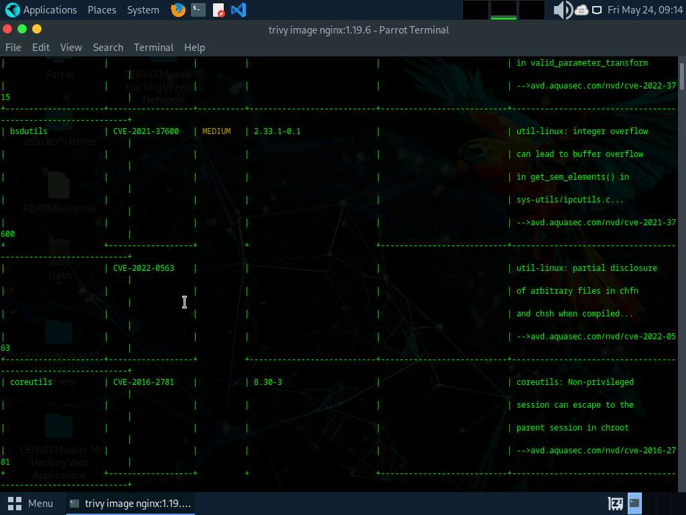
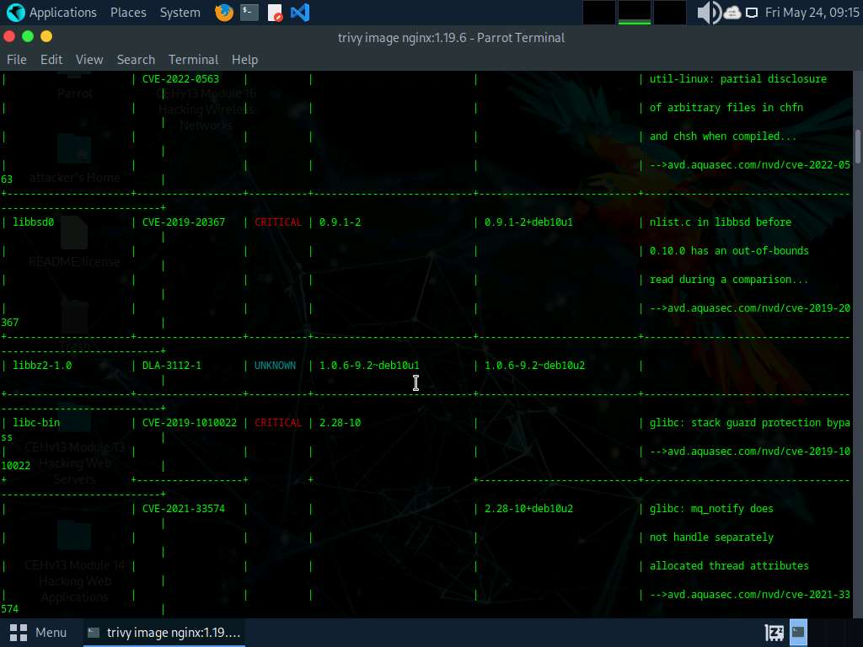
- In the above screenshot we can see that we have total 401 vulnerabilities which is categorized as well along with CVEs mentioned.
- This concludes the demonstration of vulnerability assessment on docker images using Trivy
- Close all open windows and document all acquired information.
Question 19.4.1.1
In Parrot machine install ubuntu and nginx:1.19.6 images and scan with trivy security scanner. Enter the severity level that can be observed for bsdutils vulnerability of nginx:1.19.6 docker image.

